**EXPERIMENT- 1b**

**AIM**

1. Find movies made after 1997.

2. Find movies made by Coen after 1980.

3. Find all movies and their ratings.

4. Find all actors and directors (Use UNION operator).

5. Find Coen’s movies with McDormand (Use INTERSECT operator).

6. Find the movies made after 1995 and rating greater than 8.

**CODE**

CREATE TABLE MOVIES(TITLE TEXT,DIRECTOR TEXT, MYEAR NUMBER,RATING float);

INSERT INTO MOVIES VALUES('FARGO','COEN',1996,8.2);

INSERT INTO MOVIES VALUES('RAISING ARIZONA','COEN',1987,7.6);

INSERT INTO MOVIES VALUES('SPIDERMAN','RAIMI',2002,7.4);

INSERT INTO MOVIES VALUES('WONDER BOYS','HANSON',2000,7.6);

CREATE TABLE ACTORS(ACTOR TEXT, AYEAR NUMBER);

INSERT INTO ACTORS VALUES('CAGE',1964);

INSERT INTO ACTORS VALUES('HANKS',1956);

INSERT INTO ACTORS VALUES('MAGUIRE',1975);

INSERT INTO ACTORS VALUES('MCDORMAND',1957);

CREATE TABLE ACTS(ACTOR TEXT, TITLE TEXT);

INSERT INTO ACTS VALUES('CAGE','RAISING ARIZONA');

INSERT INTO ACTS VALUES('MAGUIRE','SPIDERMAN');

INSERT INTO ACTS VALUES('MAGUIRE','WONDER BOYS');

INSERT INTO ACTS VALUES('MCDORMAND','FARGO');

INSERT INTO ACTS VALUES('MCDORMAND','RAISING ARIZONA');

INSERT INTO ACTS VALUES('MCDORMAND','WONDER BOYS');

CREATE TABLE DIRECTOR(DIRECTOR TEXT, DYEAR NUMBER);

INSERT INTO DIRECTOR VALUES('COEN',1954);

INSERT INTO DIRECTOR VALUES('HANSON',1945);

INSERT INTO DIRECTOR VALUES('RAIMI',1959);

COMMIT;

SELECT TITLE FROM MOVIES WHERE MYEAR>1997;

SELECT TITLE FROM MOVIES WHERE DIRECTOR='COEN' AND MYEAR>1980;

SELECT TITLE,RATING FROM MOVIES ;

SELECT ACTOR FROM ACTORS UNION SELECT DIRECTOR FROM DIRECTOR;

SELECT TITLE FROM MOVIES WHERE DIRECTOR='COEN' INTERSECT SELECT TITLE FROM ACTS WHERE ACTOR='MCDORMAND';

SELECT TITLE FROM MOVIES WHERE MYEAR>1995 AND RATING>8;

**OUTPUT (SCREENSHOT)**

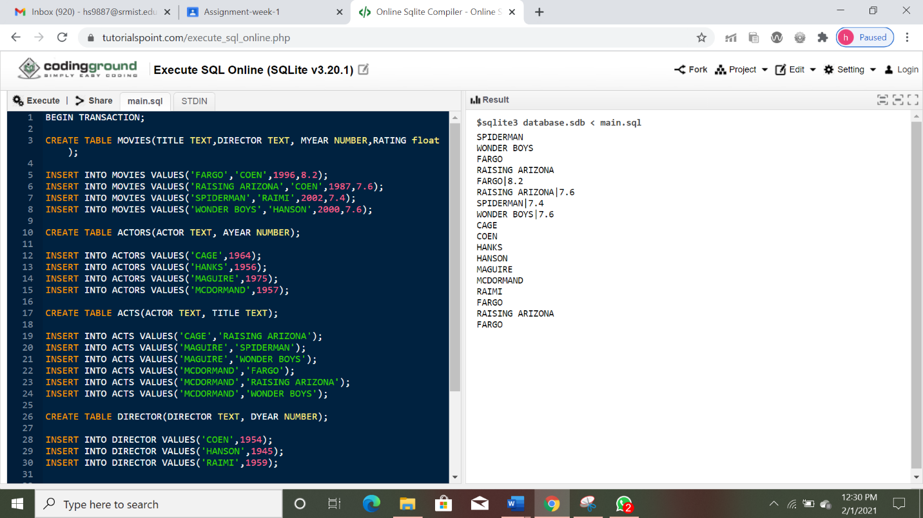

**RESULT**

The aim of the experiment to create the table and execute the queries was successfully executed on SQL online editor.